Topic: Data Cleaning and Preprocessing Pipeline Development

1. Introduction
Data cleaning and preprocessing are important steps in data science. Raw datasets may contain missing values, duplicate records, incorrect values, inconsistent formats and outliers.
The purpose of this task is to clean and prepare raw retail data using Python libraries such as Pandas, NumPy and Matplotlib.
In this week, a data cleaning and preprocessing pipeline was developed using the UCI Online Retail dataset. The dataset was inspected, cleaned and transformed to make it suitable for further analysis.

2. Objectives
- Understand the structure of the raw dataset.
- Identify and handle missing values.
- Detect and remove duplicate records.
- Identify invalid values in quantity and price.
- Detect potential outliers using statistical methods.
- Standardize product descriptions and date formats.
- Calculate sales amount.
- Save the cleaned dataset for future analysis.

3. Dataset Description
The UCI Online Retail dataset contains information about online retail transactions.
The dataset includes the following columns:
Column | Description
InvoiceNo | Invoice number
StockCode | Product code
Description | Product description
Quantity | Number of products purchased
InvoiceDate | Date and time of transaction
UnitPrice | Price per unit
CustomerID | Customer identification number
Country | Customer's country
For this practical task, the first 5,000 rows were loaded to reduce processing time in Jupyter Notebook.
Note: This is a general retail dataset, not a dataset specifically about beauty and wellness products. It is being used to demonstrate retail data cleaning techniques for the internship project.

4. Tools and Technologies Used
- Python: Programming language.
- Jupyter Notebook: Development environment.
- Pandas: Data loading, cleaning and manipulation.
- NumPy: Numerical operations.
- Matplotlib: Data visualization and outlier detection.

5. Data Loading and Inspection
First, the required libraries were imported and the dataset was loaded.
Python code:
import pandas as pdimport numpy as npimport matplotlib.pyplot as pltdf = pd.read_excel("Online Retail.xlsx", nrows=5000)print(df.shape)display(df.head())print(df.columns)df.info()print(df.isnull().sum())print(df.duplicated().sum())display(df.describe())
Explanation:
- read_excel() loads the dataset.
- head() displays the first five records.
- info() displays column names and data types.
- isnull().sum() identifies missing values.
- duplicated() identifies duplicate records.
- describe() displays statistical information.

6. Data Cleaning and Preprocessing

6.1 Handling Missing Values
Missing values were checked in all columns.
Rows with missing product descriptions were removed because product descriptions are important for product identification.
Missing CustomerID values were retained because customer identification is not required for every transaction-level calculation.
Python code:
df = df.dropna(subset=["Description"])

6.2 Removing Duplicate Records
Duplicate records can affect analysis by counting the same transaction more than once.
The duplicate records were identified and removed.
Python code:
print("Duplicates before cleaning:", df.duplicated().sum())df = df.drop_duplicates()print("Duplicates after cleaning:", df.duplicated().sum())
After cleaning, no duplicate records remained in the final dataset.

6.3 Handling Invalid Values
Quantity and UnitPrice columns were checked for negative and zero values.
Python code:
print("Negative quantities:", (df["Quantity"] < 0).sum())print("Zero quantities:", (df["Quantity"] == 0).sum())print("Negative prices:", (df["UnitPrice"] < 0).sum())print("Zero prices:", (df["UnitPrice"] == 0).sum())
Negative quantities may represent product returns or cancellations. Therefore, they should not automatically be considered errors.
For calculating positive sales, a separate dataset was created.
sales_df = df[ (df["Quantity"] > 0) & (df["UnitPrice"] > 0)].copy()

6.4 Outlier Detection
Outliers are values that are significantly different from most observations.
Boxplots were used to identify potential outliers in UnitPrice and Quantity.
Python code:
plt.boxplot(sales_df["UnitPrice"])plt.title("Outliers in Unit Price")plt.ylabel("Unit Price")plt.show()plt.boxplot(sales_df["Quantity"])plt.title("Outliers in Quantity")plt.ylabel("Quantity")plt.show()
The Interquartile Range (IQR) method was also used.
\[ IQR = Q3-Q1 \]
\[ Lower\ Limit=Q1-1.5(IQR) \]
\[ Upper\ Limit=Q3+1.5(IQR) \]
Python code:
Q1 = sales_df["UnitPrice"].quantile(0.25)Q3 = sales_df["UnitPrice"].quantile(0.75)IQR = Q3 - Q1lower_limit = Q1 - 1.5 * IQRupper_limit = Q3 + 1.5 * IQRoutliers = sales_df[ (sales_df["UnitPrice"] < lower_limit) | (sales_df["UnitPrice"] > upper_limit)]print("Potential price outliers:", len(outliers))
Potential outliers were identified for further inspection rather than automatically deleted, because some unusually high prices or quantities may be valid transactions.

6.5 Data Standardization
Product descriptions were standardized by removing extra spaces and formatting the text consistently.
InvoiceDate was converted into a proper date-time format.
Python code:
sales_df["Description"] = ( sales_df["Description"] .astype("string") .str.strip() .str.title())sales_df["InvoiceDate"] = pd.to_datetime( sales_df["InvoiceDate"], errors="coerce")

6.6 Feature Creation
A new column called SalesAmount was created.
It calculates the total amount for each transaction line.
\[ SalesAmount=Quantity\times UnitPrice \]
Python code:
sales_df["SalesAmount"] = ( sales_df["Quantity"] * sales_df["UnitPrice"])

6.7 Saving the Cleaned Dataset
The cleaned dataset was saved in CSV format.
Python code:
sales_df.to_csv( "Beauty_Wellness_Cleaned_Data.csv", index=False)print("Cleaned dataset saved successfully!")

7. Data Preprocessing Flowchart
Start
Load Retail Dataset
Inspect Data and Missing Values
Remove Missing Descriptions and Duplicates
Check Invalid Values and Outliers
Standardize Data and Create SalesAmount
Validate and Save Cleaned Dataset
End

8. Final Dataset Results
After performing the cleaning and preprocessing operations, the following results were obtained from Jupyter Notebook.
Parameter | Result
Final dataset rows | 4,839
Final dataset columns | 9
Duplicate records | 0
Missing Description | 0
Missing CustomerID | 1,193
Missing values in other displayed columns | 0
SalesAmount records | 4,839

Sales Amount Statistical Summary
Statistical measure | Value
Count | 4,839
Mean | 21.443213
Standard Deviation | 62.849136
Minimum | 0.29
25% | 4.21
Median (50%) | 10.50
75% | 17.85
Maximum | 1,627.20
Result interpretation:
- The final cleaned dataset contains 4,839 records and 9 columns.
- No duplicate records remain.
- All retained records have product descriptions.
- CustomerID has 1,193 missing values, which were retained.
- The average SalesAmount is approximately 21.44.
- The maximum SalesAmount is 1,627.20, which may require further investigation.
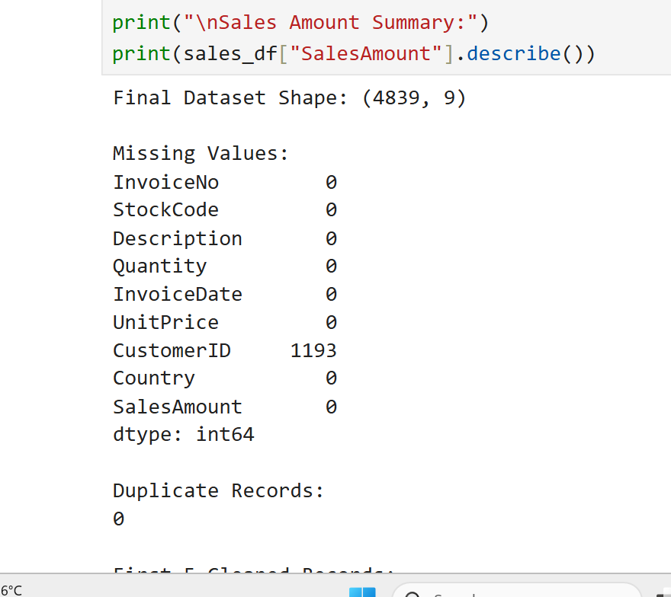

9. Importance of Data Cleaning
Data cleaning is important because:
- It improves data accuracy and reliability.
- It removes duplicate records.
- It helps handle missing and invalid values.
- It improves the quality of data visualization.
- It prepares the dataset for statistical analysis.
- It helps improve the reliability of future machine learning models.

10. Reproducibility
The preprocessing pipeline can be repeated using the same source dataset and Python code.
The cleaned dataset is saved as a CSV file so that it can be reused in future analysis.
The use of Pandas functions makes the process simple, organized and repeatable.

11. Limitations
- Only the first 5,000 rows of the original dataset were used.
- The dataset represents general retail transactions, not specifically beauty and wellness purchases.
- Some CustomerID values are missing.
- Potential outliers were identified but not automatically removed.
- Further analysis with a beauty and wellness-specific dataset is needed to understand actual industry trends.

12. Conclusion
In this week, a data cleaning and preprocessing pipeline was successfully developed using Python.
The UCI Online Retail dataset was inspected, cleaned and transformed using Pandas, NumPy and Matplotlib. Missing product descriptions and duplicate records were handled. Invalid quantity and price values were checked, potential outliers were identified, and data formats were standardized.
A new SalesAmount column was created to calculate transaction line amounts. Finally, the cleaned dataset was saved in CSV format.
This task provided practical knowledge of data preprocessing and prepared the dataset for further retail data analysis.

13. References
- UCI Machine Learning Repository – Online Retail Dataset: https://archive.ics.uci.edu/dataset/352/online+retail
- Pandas Documentation: https://pandas.pydata.org/docs/
- NumPy Documentation: https://numpy.org/doc/
- Matplotlib Documentation: https://matplotlib.org/stable/

